**MIDDLE EAST TECHNICAL UNIVERSITY**

**DEPARTMENT OF ELECTRICAL & ELECTRONICS ENGINEERING**



**TROY TECH**

**WEEKLY REPORT #7**

**30.03.2019-05.04.2019**

**Section :** 7

**Studio Coordinator:** Mustafa Mert ANKARALI

**Partners :**

Hasan ÖZKARA - 2031888

Kağan ÖZASLAN - 2031854

Caner POTUR - 2031250

Mustafa Ercan OKATAN - 2031193

Mert KAYIŞ – 2030997

**Progresses for Previous Week:**

→ We completed and tested the shooting system. It worked well:

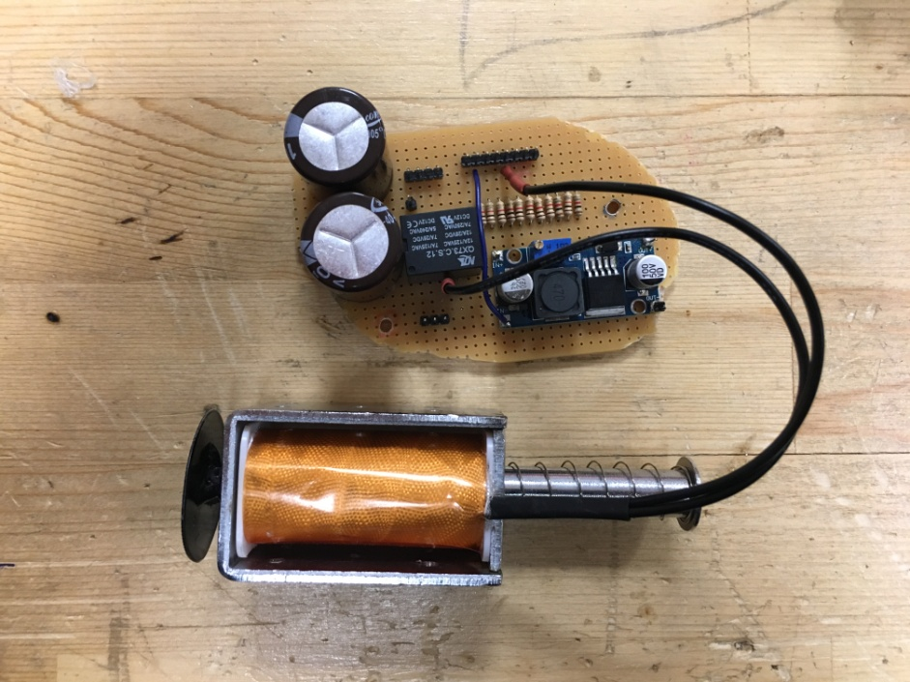

→ We implemented all subsystems to the body. We drilled the body at specific location which is appropriate for connections of the components in different layers:

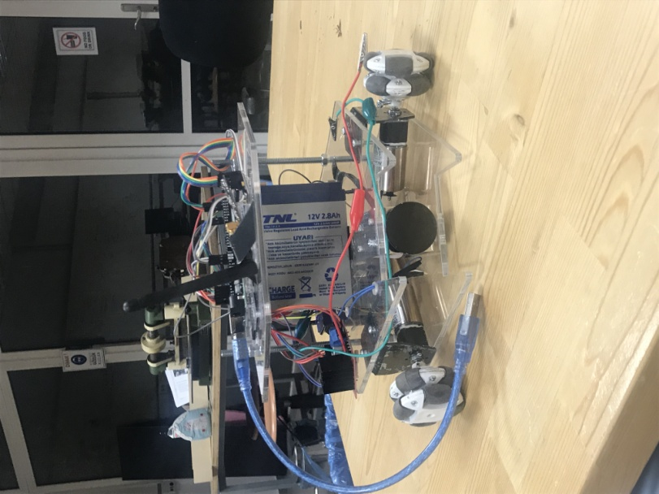

→ We decided to mount the camera just above the shooting solenoid since we ensured that it is the best position for camera view ( we can see our shooting place, ball, and the entire

playfield) after the several test.

→ We wrote down the which pins are connected to each other and we designed the cable paths and other connection elements in order to have a neat structure.

→We worked on movement system. Using left-analog of PS1 joystick, the robot can go 8 directions. Moreover, R1 and R2 buttons can increase/decrease the speed of robot.

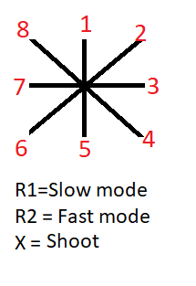

→ Some videos of our robot:

https://vimeo.com/328616865

https://vimeo.com/328616716

https://vimeo.com/328616407

password: troy

**Plans for Next Week:**

- Overall system testing

- Improving movement system

- Discussing and reassigning the buttons of joystick